### A000-Eur-France-Le Grand Pressigny-Projectile Point-Mid. Paleolithic-Mousterian phase-ca 60-40 kya

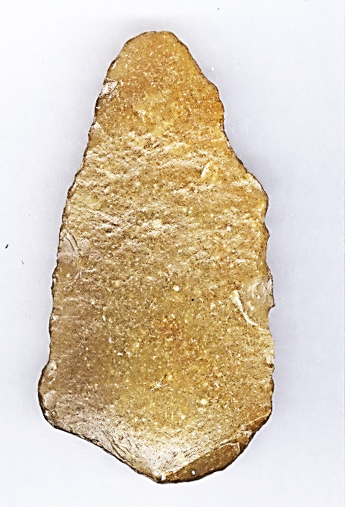 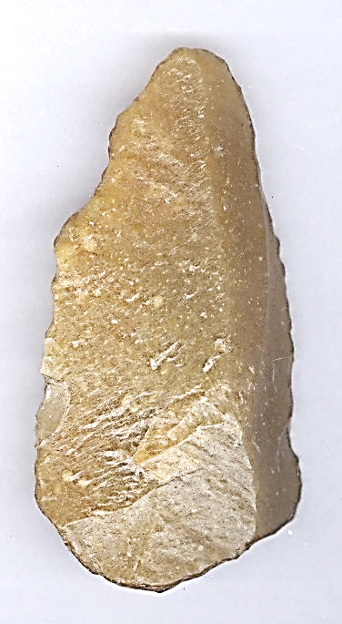

### Fig. 1. France-Le Grand Pressigny-Projectile Point-Middle Paleolithic-Mousterian phase-ca 60,000 BP- 40,000 BP, ventral view; Fig. 2. Same, dorsal view.

### **Formal Label:** France-Le Grand Pressigny-Projectile Point-Middle Paleolithic-Mousterian phase-ca 60,000 BP-40,000 BP

### **Display Description:** This unifacial, triangular, median-ridged projectile point is an example of an Acheulian tool made from Le Grand Pressigny flint by striking the core, and then manipulating a large flake to produce two angles converging to the point. Some retouch is evident to make the point sharper. LeGrand Pressigny is the eponymous name of a flint industry known since 1863 for its flint which was used beginning in the Middle Paleolithic, Mousterian phase, ca 60,000 BP- 40,000 BP. This point was probably made by Homo erectus for use with an atlatl judging by its weight.

### **Accession Number:**

**LC Classification:** GN776.22.F7

### **Date or Time Horizon:** ca 60,000 BP-40,000 BP.

**Geographical Area:** Le Grand Pressigny, France.

**Map, GPS coordinates:** [46 ° 55 '19 "North](https://translate.googleusercontent.com/translate_c?depth=1&hl=en&prev=search&rurl=translate.google.com&sl=fr&sp=nmt4&u=http://tools.wmflabs.org/geohack/geohack.php%3Flanguage%3Dfr%26pagename%3DMus%25C3%25A9e_de_la_Pr%25C3%25A9histoire_du_Grand-Pressigny%26params%3D46.921809_N_0.803508_E_type:landmark_region:FR&usg=ALkJrhgTi55y0QOKYbuJSjEaIs86gAUBfA) [,](https://translate.googleusercontent.com/translate_c?depth=1&hl=en&prev=search&rurl=translate.google.com&sl=fr&sp=nmt4&u=http://tools.wmflabs.org/geohack/geohack.php%3Flanguage%3Dfr%26pagename%3DMus%25C3%25A9e_de_la_Pr%25C3%25A9histoire_du_Grand-Pressigny%26params%3D46.921809_N_0.803508_E_type:landmark_region:FR&usg=ALkJrhgTi55y0QOKYbuJSjEaIs86gAUBfA) [0 ° 48 '13 "](https://translate.googleusercontent.com/translate_c?depth=1&hl=en&prev=search&rurl=translate.google.com&sl=fr&sp=nmt4&u=http://tools.wmflabs.org/geohack/geohack.php%3Flanguage%3Dfr%26pagename%3DMus%25C3%25A9e_de_la_Pr%25C3%25A9histoire_du_Grand-Pressigny%26params%3D46.921809_N_0.803508_E_type:landmark_region:FR&usg=ALkJrhgTi55y0QOKYbuJSjEaIs86gAUBfA).



Fig. 3. Map of Le Grand Pressigny area.

**Cultural Affiliation: Acheulian**

**Medium:** Le Grand Pressigny Flint.

**Dimensions: H 67.97 mm, W 36.79 mm, T13.54; H2.675 in, W 1.648 in, T 0.533 in   
Weight: 31 gm, 1 oz.**

**Provenance: from an old Belgian collection of Le Grand Pressigny flint tools**.

**Condition:** original. **This projectile point has a** beautiful dark patina and soil sheen on the original surfaces with no modern damage or repair.

**Discussion:** The first hominins to live outside of Africa were *Homo erectus* ca 1.8 Ma and they diffused over a wide area of Western Europe. Homo erectus arrived in Europe when stone tool technology included both Acheulian flake tools and the earlier Oldowan style pebble tools.  Between 700,000 and 400,000 BP, the first hand-axes were made by *Homo erectus* in Europe.

In the Neolithic period finished blades and daggers were a prized medium of exchange.

**References:**

Louboutin, C. 2011. Archeology of the Touraine. Éditions La Simarre

Mallet, Nicole. 1992. *Grand-Pressigny: ses relations avec la civilisation Saône-Rhône*. [Argenton-sur-Creuse?]: Amis du Musée de préhistoire du Grand-Pressigny. v.1. Texte -- v. 2. Planches.

Steenstrup and John Lubbock. 1867. “On the Flint Implements Recently Discovered at Pressigny-le-Grand,” *Transactions of the Ethnological Society of London*, 5: 221-227.